**EMAIL AUTOMATION WITH RPA**

Project Description:

This project is used to automate the entire process of sending mails using gmail or outlook with the help of Blue Prism Tool. The outcome of the projects are 

* To auto login to your G-mail
* To add the attachment to the mail
* To send the emails.

**Steps should be followed:**

1: The security setting of the gmail account has been enabled as less security app

2: Using Process Studio created a Process object with following components

i) Two data items were dragged and initialized with "Username" and "Password"   of the composer email accounts

           ii) The Business object named "Email-SMTP/POP3 VBA Component is imported

                from the repository

          iii) The Action control is dragged from the tool box and it was initialized with the

               Email Configuration setting of Gmail as

               smtp.gmail.com with port 587 and pop.gmail.com with port 995

          iv) The control components named Collection is dragged and dropped in

the  panel for the purpose of associating the attachments we want to attach

with the e- mail

         v).Another Action component is dragged and dropped as the next sequence link

             and assigned with From email account, To email account, Subject, Body and

for   attachment the collection component is associated with this action

3: Debug the program if you encounter the error.

4: If no Errors, the project is working properly.

5: Finally the mail received as specified in the panel configuration

 The screen shot has been attached with this

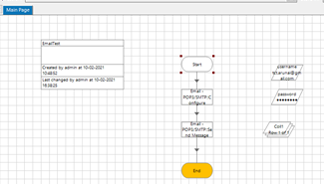

Email Configuration Setting

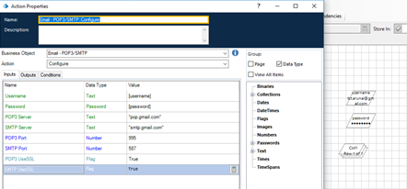

Email Send Message Setting

